

# 

### Semester Two Examination, 2018

### Question/Answer booklet

# MATHEMATICS

**SOLUTIONS**

**APPLICATIONS**

**UNITS 3 AND 4**

## Section One:

## Calculator-free

|  |  |  |  |  |  |  |  |  |  |  |
| --- | --- | --- | --- | --- | --- | --- | --- | --- | --- | --- |
| Student number: In figures |  |  |  |  |  |  |  |  |  |  |

In words

Your name

## Time allowed for this section

Reading time before commencing work: five minutes

Working time: fifty minutes

## Materials required/recommended for this section

***To be provided by the supervisor***

This Question/Answer booklet

Formula sheet

***To be provided by the candidate***

Standard items: pens (blue/black preferred), pencils (including coloured), sharpener,  
correction fluid/tape, eraser, ruler, highlighters

Special items: nil

## Important note to candidates

No other items may be taken into the examination room. It is **your** responsibility to ensure that you do not have any unauthorised material. If you have any unauthorised material with you, hand it to the supervisor **before** reading any further.

## Structure of this paper

|  |  |  |  |  |  |
| --- | --- | --- | --- | --- | --- |
| Section | Number of questions available | Number of questions to be answered | Working  time (minutes) | Marks available | Percentage of examination |
| Section One:  Calculator-free | 7 | 7 | 50 | 51 | 35 |
| Section Two:  Calculator-assumed | 12 | 12 | 100 | 99 | 65 |
|  | | |  | **Total** | 100 |

## Instructions to candidates

1. The rules for the conduct of examinations are detailed in the school handbook. Sitting this examination implies that you agree to abide by these rules.

2. Write your answers in this Question/Answer booklet.

3. You must be careful to confine your response to the specific question asked and to follow any instructions that are specified to a particular question.

4. Supplementary pages for the use of planning/continuing your answer to a question  
have been provided at the end of this Question/Answer booklet. If you use these pages to continue an answer, indicate at the original answer where the answer is continued, i.e. give the page number.

5. Show all your working clearly. Your working should be in sufficient detail to allow your answers to be checked readily and for marks to be awarded for reasoning. Incorrect answers given without supporting reasoning cannot be allocated any marks. For any question or part question worth more than two marks, valid working or justification is required to receive full marks. If you repeat any question, ensure that you cancel the answer you do not wish to have marked.

6. It is recommended that you do not use pencil, except in diagrams.

7. The Formula sheet is not to be handed in with your Question/Answer booklet.

Section One: Calculator-free 35% (51 Marks)

This section has**seven (****7)** questions. Answer **all** questions. Write your answers in the spaces provided.

Working time: 50 minutes.

Question 1 (7 marks)

(a) The following bipartite graph shows the subjects studied by three students. Redraw the graph to clearly show the two distinct sets of vertices and hence state which vertices represent the subjects studied. (3 marks)

|  |
| --- |
| **Solution** |
| Subjects are represented by and . |
| **Specific behaviours** |
| ✓ clearly shows the two sets of vertices  ✓ correct edges  ✓ correctly identifies subject vertices |

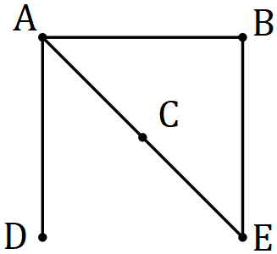

(b) The complete bipartite graph denoted by has vertices in one set and vertices in the other set.

(i) Draw and state whether the graph is Eulerian, semi-Eulerian or neither.

(2 marks)

|  |
| --- |
| **Solution** |
| Graph is Eulerian |
| **Specific behaviours** |
| ✓ correct graph  ✓ correct identification |

(ii) Draw and state whether the graph is Hamiltonian, semi-Hamiltonian or neither.

|  |
| --- |
| **Solution** |
| Graph is semi-Hamiltonian |
| **Specific behaviours** |
| ✓ correct graph  ✓ correct identification |

(2 marks)

Question 2 (9 marks)

(a) The first two terms of an arithmetic sequence are displayed in the table below.

|  |  |  |  |  |
| --- | --- | --- | --- | --- |
|  |  |  |  |  |
|  |  |  |  |  |

(i) Add the next two terms to the table. (2 marks)

|  |
| --- |
| **Solution** |
| See table |
| **Specific behaviours** |
| ✓ correct difference  ✓ both values consistent with difference |

(ii) Deduce a rule for the term of this sequence. (1 mark)

|  |
| --- |
| **Solution** |
|  |
| **Specific behaviours** |
| ✓ correct rule |

(b) The first two terms of a geometric sequence are displayed in graphical form below. Plot the likely position of the next three terms of the sequence on the graph. (2 marks)

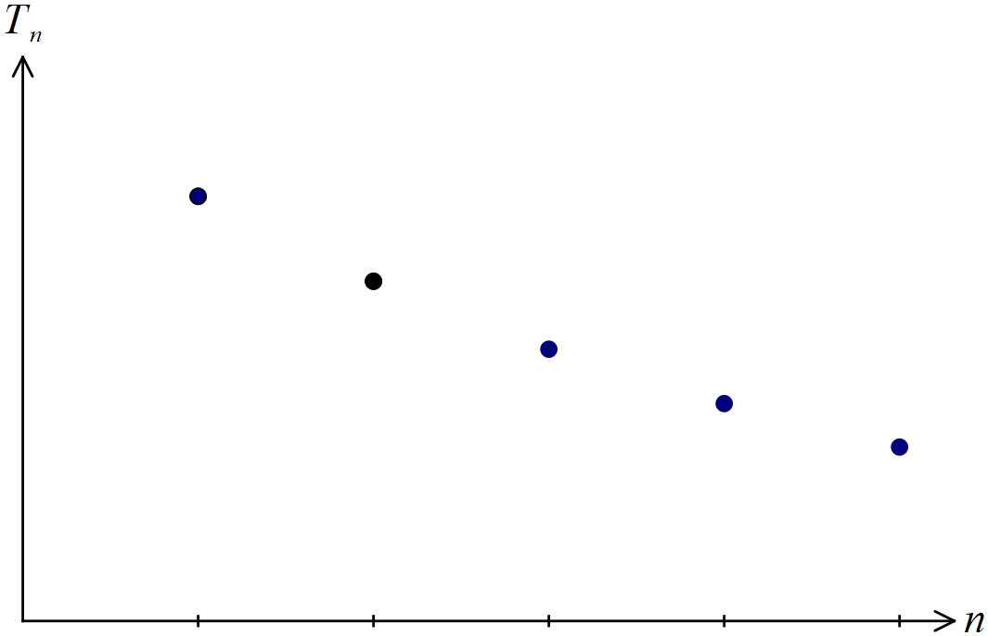

|  |
| --- |
| **Solution** |
| See graph |
| **Specific behaviours** |
| ✓ correct horizontal spacing  ✓ points form smooth, upwards curve |

(c) A first-order linear recurrence relation is defined by .

(i) Determine the second and third terms of the sequence. (2 marks)

|  |
| --- |
| **Solution** |
|  |
| **Specific behaviours** |
| ✓ second term  ✓ third term |

(ii) In the long-term, the terms of the sequence become very close to . Determine, with justification, the value of . (2 marks)

|  |
| --- |
| **Solution** |
|  |
| **Specific behaviours** |
| ✓ forms correct equation using  ✓ correct value of |

Question 3 (7 marks)

The graph below shows a time series plot, where is the number of breakdowns of a printing machine that are recorded during month .

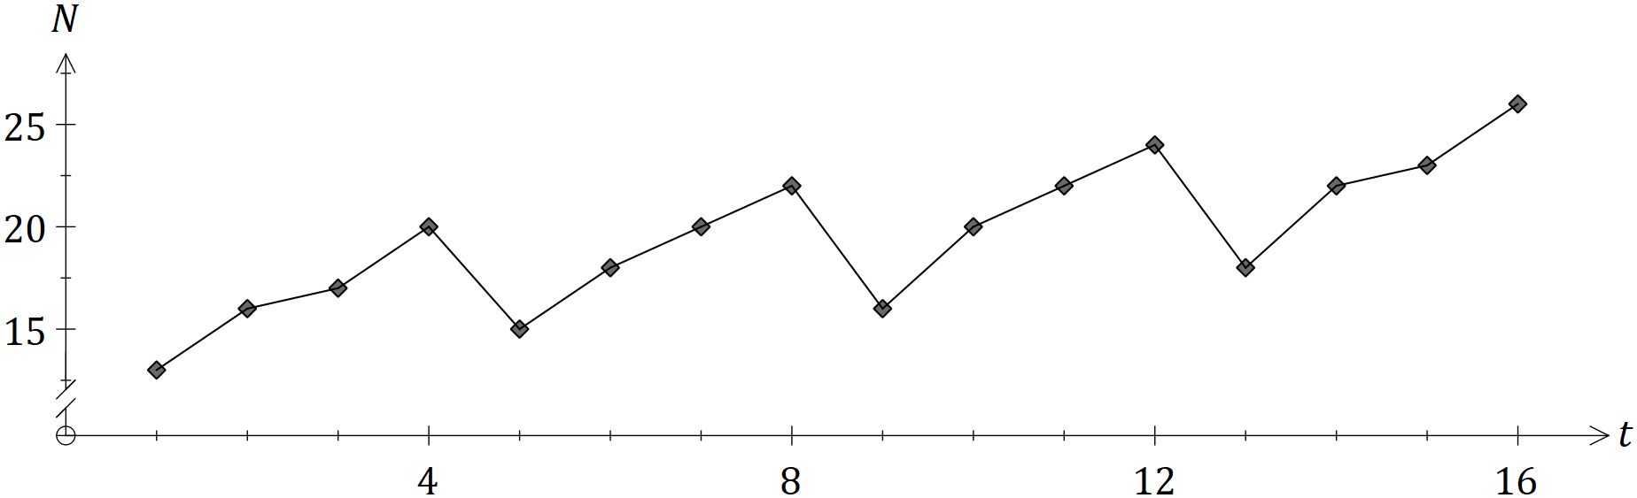

(a) Describe the seasonality and trend of the time series. (2 marks)

|  |
| --- |
| **Solution** |
| Cycles of 4 months are evidenced by an increase followed by a decrease.  As time goes on, an underlying increasing trend is apparent. |
| **Specific behaviours** |
| ✓ indicates seasonality by referring to 4-month cycles  ✓ indicates increasing trend |

(b) Some of the data is given in the table below.

|  |  |  |  |  |  |  |
| --- | --- | --- | --- | --- | --- | --- |
|  |  |  |  |  |  |  |
|  |  |  |  |  |  |  |

(i) Calculate the -point centred moving average for . (2 marks)

|  |
| --- |
| **Solution** |
|  |
| **Specific behaviours** |
| ✓ indicates appropriate method for centring  ✓ correct average |

(ii) Explain the purpose of calculating simple moving averages for a time series.

(2 marks)

|  |
| --- |
| **Solution** |
| To smooth the data and hence expose the underlying trend. |
| **Specific behaviours** |
| ✓ smoothing  ✓ exposing trend |

(iii) Explain the purpose of centring a -point moving average. (1 mark)

|  |
| --- |
| **Solution** |
| To align the moving average with time. |
| **Specific behaviours** |
| ✓ valid reason |

Question 4 (8 marks)

(a) Comment, with reasons, on the claim that the graph shown below is simple, planar and satisfies Euler's formula. (3 marks)

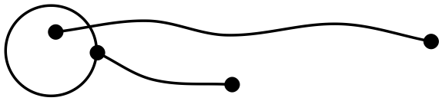

|  |
| --- |
| **Solution** |
| Not simple - contains a loop  Is planar - can be drawn with no edges crossing  Doesn't satisfy Euler's formula, as it is not connected or |
| **Specific behaviours** |
| ✓ reason for not simple  ✓ reason for being planar  ✓ reason for not satisfying Euler's |

(b) A graph has vertices and edges. Determine the sum of the degrees of the vertices.

(1 mark)

|  |
| --- |
| **Solution** |
|  |
| **Specific behaviours** |
| ✓ correct sum |

(c) Draw a semi-Eulerian graph that has vertices and is a tree. (2 marks)

|  |
| --- |
| **Solution** |
| *Example:* |
| **Specific behaviours** |
| ✓ semi-Eulerian  ✓ tree with vertices |

(d) Draw a connected planar graph that has vertices, faces and bridge. (2 marks)

|  |
| --- |
| **Solution** |
| *Example:* |
| **Specific behaviours** |
| ✓ connected, bridge  ✓ vertices, faces |

Question 5 (8 marks)

The vertices in the graph below represent city landmarks and the weights on the edges are the times, in minutes, to travel between adjacent landmarks.

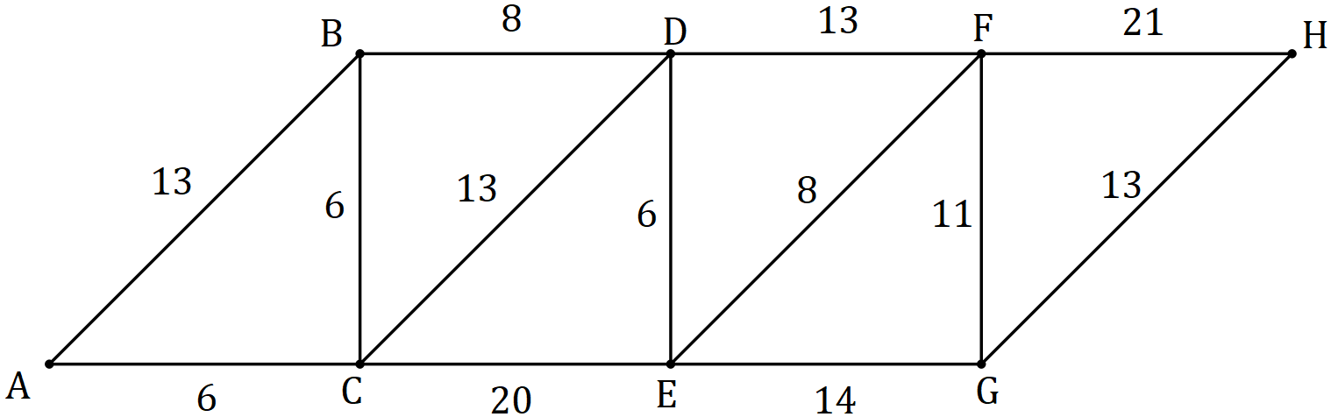

(a) Determine the shortest time to travel from to . (3 marks)

|  |
| --- |
| **Solution** |
|  |
| **Specific behaviours** |
| ✓ lists a path with correct time  ✓ lists another path with correct time  ✓ indicates the correct shortest time |

(b) The travel times from to and from to both increase by minutes. Explain how these changes affect your answer to (a). (2 marks)

|  |
| --- |
| **Solution** |
| increase has no effect as edge not used.  changes path to and increases time by 1 min (to 53 mins). |
| **Specific behaviours** |
| ✓ indicates no effect for  ✓ indicates time increase for |

(c) Construct the adjacency matrix for the subgraph shown below, using column and row headings in the order . (2 marks)

|  |
| --- |
| **Solution** |
|  |
| **Specific behaviours** |
| ✓ symmetrical entries  ✓ all entries correct |

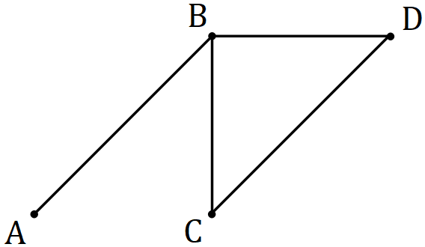

(d) If matrix , determine the value of . (1 mark)

|  |
| --- |
| **Solution** |
| *(Since no walk from to along edges)* |
| **Specific behaviours** |
| ✓ correct value |

Question 6 (6 marks)

Three trucks, selected from a choice of four, are to be used to carry sand from a quarry to three building sites. The table below shows the weight of sand that each truck can carry to each site per day.

|  |  |  |  |  |
| --- | --- | --- | --- | --- |
|  | Truck 1 | Truck 2 | Truck 3 | Truck 4 |
| Site A |  |  |  |  |
| Site B |  |  |  |  |
| Site C |  |  |  |  |

Use the Hungarian algorithm to show that the maximum amount of sand that can be transported to the three sites is tonnes per day and state the required allocation of trucks to achieve this maximum.

|  |
| --- |
| **Solution** |
| Subtract from maximum (47) and add dummy row:   |  |  |  |  |  | | --- | --- | --- | --- | --- | |  | 1 | 2 | 3 | 4 | | A |  |  |  |  | | B |  |  |  |  | | C |  |  |  |  | | - |  |  |  |  |   Reduce rows 1 & 2:   |  |  |  |  |  | | --- | --- | --- | --- | --- | |  | 1 | 2 | 3 | 4 | | A |  |  |  |  | | B |  |  |  |  | | C |  |  |  |  | | - |  |  |  |  |   Cover with 3 lines (shaded above) - smallest uncovered number is 1.  Reduce again (subtract 1 from uncovered, add to twice covered):   |  |  |  |  |  | | --- | --- | --- | --- | --- | |  | 1 | 2 | 3 | 4 | | A |  |  |  |  | | B |  |  |  |  | | C |  |  |  |  | | - |  |  |  |  |   Make assignment (shaded above):  Truck 1 - not used  Truck 2 - to site B (41)  Truck 3 - to site A (44)  Truck 4 - to site C (47)  Total tonnage: |
| **Specific behaviours** |
| ✓ subtracts from maximum  ✓ adds dummy row  ✓ reduces rows  ✓ covers with 3 lines  ✓ reduces again  ✓ states assignment, showing values that make total |

Question 7 (6 marks)

A connected graph has vertices and edges. The vertices represent towns and the edges represent roads between the towns. The lengths of the edges, in kilometres, are:

(a) Determine the minimum possible length of a Hamiltonian cycle for such a graph.

(2 marks)

|  |
| --- |
| **Solution** |
|  |
| **Specific behaviours** |
| ✓ indicates use of shortest six edges  ✓ correct total |

(b) Draw a possible graph, given that that it is also simple and has a minimum spanning tree of length km. Clearly label the edge lengths and highlight the minimum spanning tree. (4 marks)

|  |
| --- |
| **Solution** |
| Example (MST can be or ) |
| **Specific behaviours** |
| ✓ no multiple edges or loops  ✓ connected graph with and  ✓ labels and highlighted MST  ✓ length of MST is |

Supplementary page

Question number: _________

Supplementary page

Question number: _________

© 2018 WA Exam Papers. Kennedy Baptist College has a non-exclusive licence to copy and communicate this document for non-commercial, educational use within the school. No other copying, communication or use is permitted without the express written permission of WA Exam Papers. SN245-126-2.